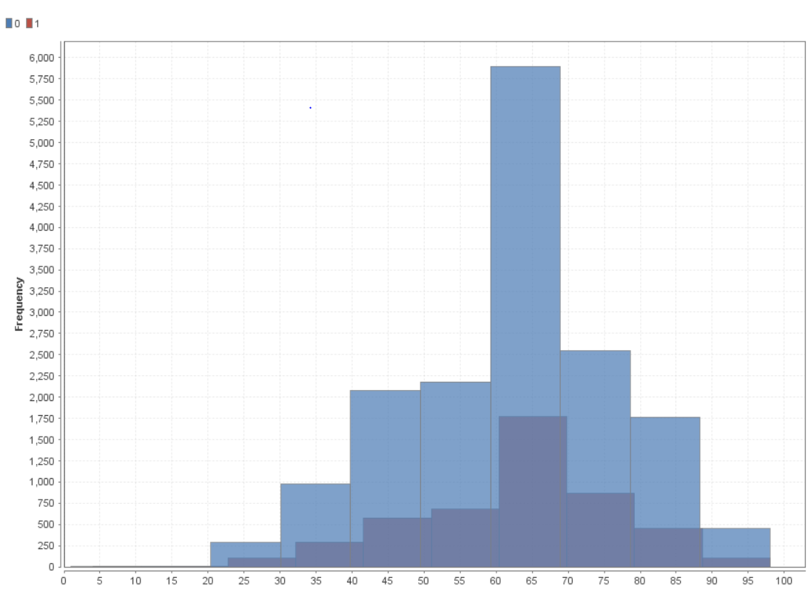

Apart from the missing values, a

normal distribution can be observed

for both Age of Donor and Donation

Response i.e., Donors of all age

groups can be targeted for

promotion.

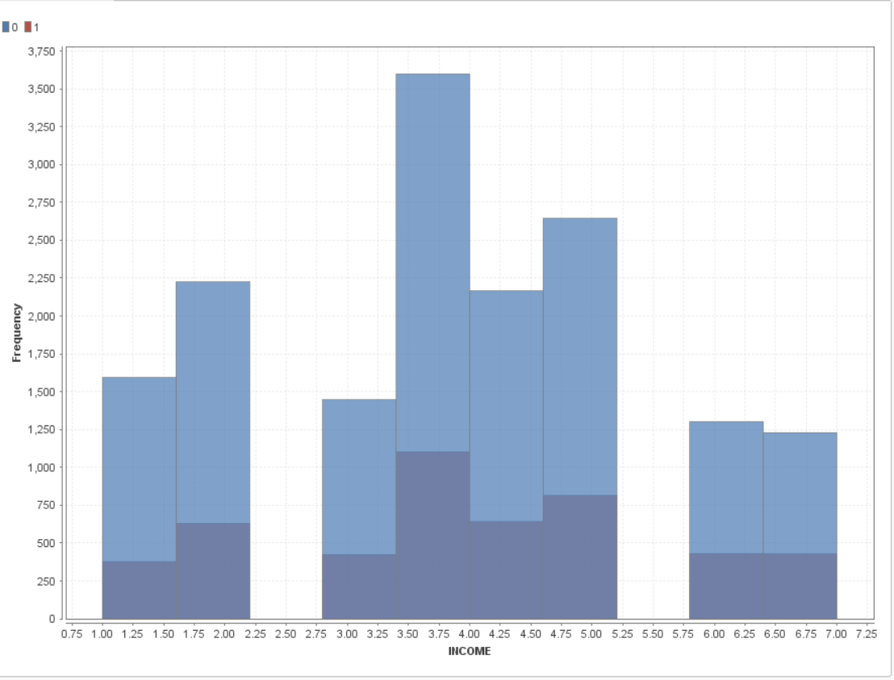

Except the missing values, An

Increasing trend can be observed in

the income and the donation

response variables.

Donors from higher income groups

are more likely to respond to a

donation mail.

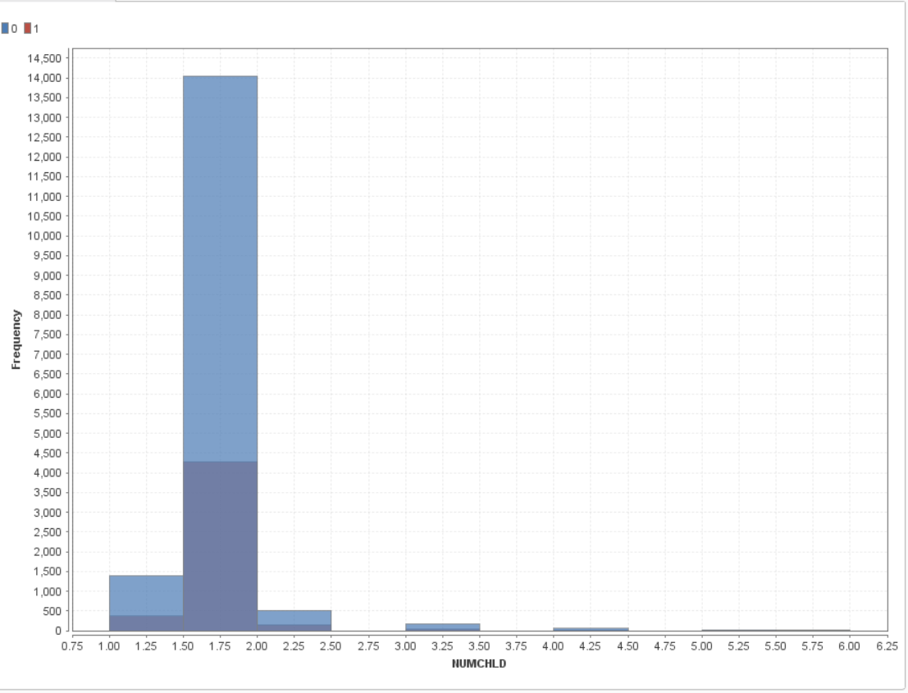

The average number of children is approximately 2 having a standard deviation of 0.78 which means that donors with 1-3 children donate more than those with more than 3 children.

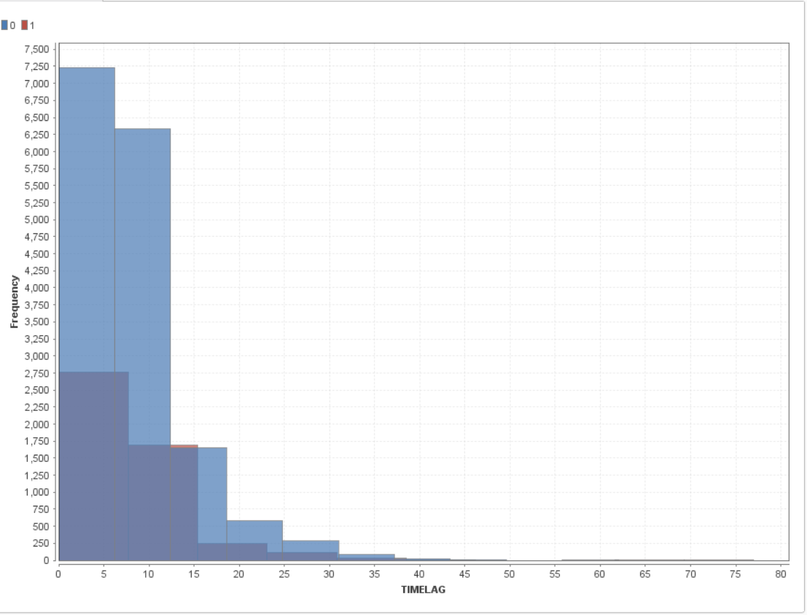

TIMELAG shows a mean of 8 which could be interpreted as the fact that donors donate in 8 months. Hence, mails should be sent as frequently as possible.

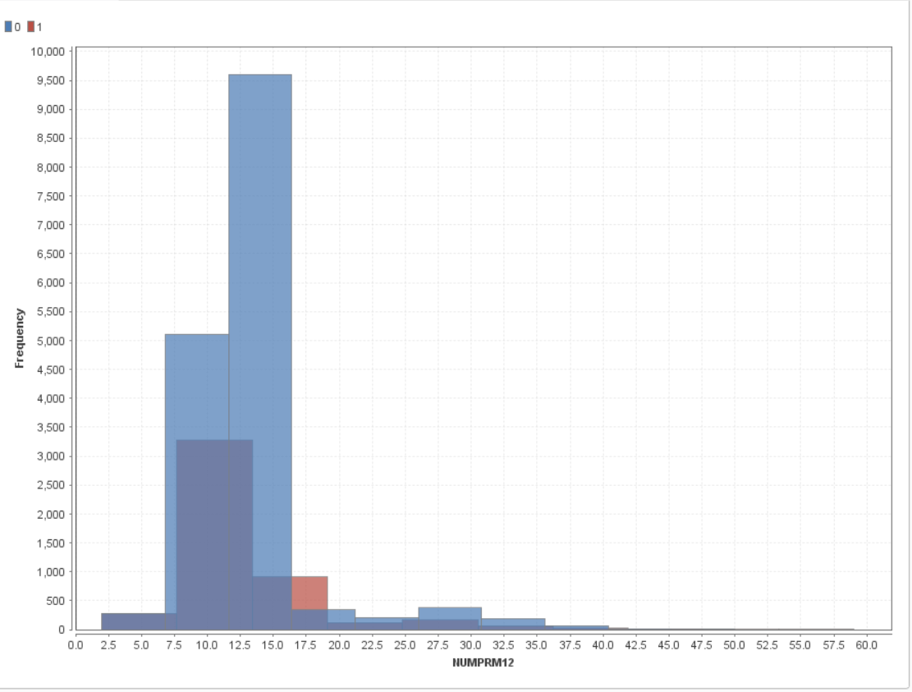

Response patterns were observed to vary if the number of promotions sent,

especially in the last 12 months.

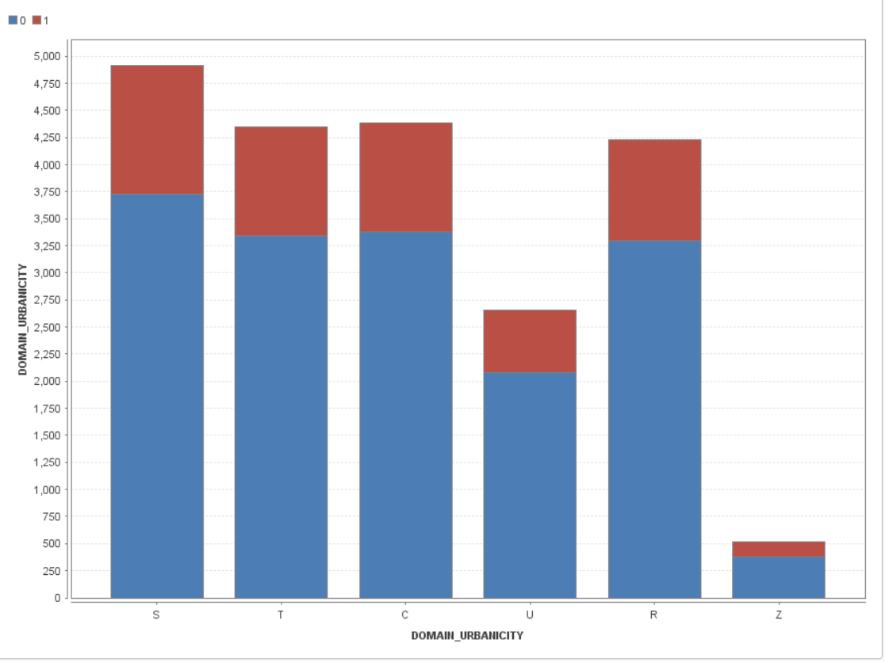

It can be seen that, except for the

urban level of the Urbanicity all

others have similar percentage of

response.